Variation of environmental parameters in Tuva inlet

All environmental variables included in our analysis could be divided into three groups. The first one (*Depth, Slope*, *Exp* and *Width*) is associated with the geomorphology of the inlet. The most flattened shores (low Slope values combined with large Width) were presented in the inner part of the inlet next to the river mouth. More steep and narrow shores  situated at the inlet entrance. Samples at different littoral levels on more vertical and narrow transects (next to inlet mouth) positioned closer to each other (only few meters between samples) in comparison with samples from more horizontal and broader shores in the inner part of the inlet where hundreds meters  separated different sampling localities (Fig. +++). Both “north” and “south” shores are not completely symmetric. It is obvious from the area map (Fig. +++) that “north” shore is more steep. It is well seen  that the river course is pushed close to the north shore.

The second group of parameters (Kelp, Bottom, Cov) describe some bionomic characteristics of a sampling locality. Soft sediments are more expressed on the extensive intertidal flats in the inner part of the inlet whereas hard substrates prevail next to the inlet entrance. Bottom surface can be covered in different degrees with algae of different species (fucales, filamentous algae). Kelp forests are expressed on sublitoral hard substrates only.

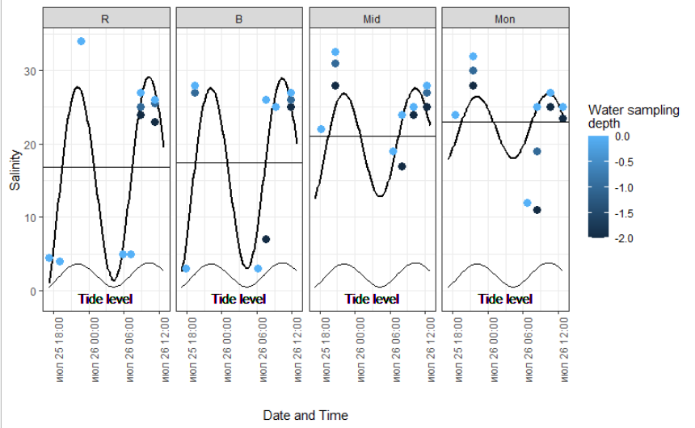

Obvious gradient of environmental parameters is associated with the “entrance - top” axis of the inlet. This gradient is summarized in the parameter “Distance”, forming the third group of environmental variables. The most obvious factor associated with the “Distance” variable is salinity.  Freshwater discharge due to the Tuva river defines the salinity gradient. The mean salinity increases from approximately 16 psu in the inner part of the inlet  up to 23 psu next to its entrance (Fig. ++).

However this pattern is complicated by tidal currents which drive the salinity variation during the ebb and flow cycle. The salinity variation is more expressed in the inner part of the  inlet (Fig. +++). The salinity remarkably decreases during the ebb phase (Fig. ++). Thus mussel settlements situated in the inner part of the inlet  are washed by highly freshened water during the low tide. During the flow phase salinity increases up to nearly normal oceanic level both on the water surface and to depth up to 2 meters (Fig.++).

The pattern of salinity dynamics described allows to state that different littoral levels are situated in different salinity regimes.  The highest levels of the littoral which are covered by water only during the high tide are washed mostly by normally salinated water. The influence of the freshwater on the highest littoral levels seems to be negligible and expressed only during the short period at the beginning of ebb phase when salinity started to decrease but the upper littoral parts is steel covered by water. The lower levels of the littoral zone are exposed to the influence of fresh water but mostly during the low tide. The sublittoral part of the inlet seems to be exposed to desalinization only in the inner region during the ebb phase.